CS 340 Project Two: Grazioso Salvare Dashboard
Daniel Cervantes
Southern New Hampshire University
CS 340: Client/Server Development
For this project, I created an interactive dashboard for Grazioso Salvare using Python, MongoDB, and Dash. The purpose of the dashboard is to help the organization identify animals that meet specific rescue training requirements. Instead of searching through the animal shelter database manually, users can select a rescue category and view animals that match the requirements.
The dashboard includes an interactive data table, rescue type filters, a pie chart showing animal breeds, and a map displaying the selected animal's location. I also connected the dashboard to the CRUD Python module I developed earlier in the course, allowing the application to retrieve animal records from MongoDB.
The main goal of this project was to create a dashboard that makes the animal shelter data easier to access, filter, and understand.
Dashboard Features and Rescue Filters
The Grazioso Salvare dashboard allows users to search through animal shelter records using four rescue filter options. Each filter retrieves information from MongoDB based on the animal's breed, sex, and age. The dashboard then updates the data table, pie chart, and map to display the results.
Water Rescue: This filter searches for Labrador Retriever Mix, Chesapeake Bay Retriever, and Newfoundland dogs. The animals must be intact females between 26 and 156 weeks old.
Mountain/Wilderness Rescue: This filter searches for German Shepherd, Alaskan Malamute, Old English Sheepdog, Siberian Husky, and Rottweiler dogs. The animals must be intact males between 26 and 156 weeks old.
Disaster/Individual Tracking: This filter searches for Doberman Pinscher, German Shepherd, Golden Retriever, Bloodhound, and Rottweiler dogs. The animals must be intact males between 20 and 300 weeks old.
Reset: This option removes the rescue filters and displays the complete animal shelter dataset again.
The interactive data table allows users to sort, search, and select animal records. The pie chart shows the distribution of breeds in the filtered results. To keep the chart readable when viewing the complete dataset, I grouped the less common breeds into an Other category.
The map displays the location of the animal selected in the data table. When a different animal is selected, the map updates to show its location. Clicking the map marker also displays the animal's name.
MongoDB Connection and CRUD Python Module
For this project, I used MongoDB to store the animal shelter records and connected the database to my dashboard through the CRUD_Python_Module.py file. This module contains the AnimalShelter class, which I developed earlier in the course to perform Create, Read, Update, and Delete (CRUD) operations.
The dashboard uses the read() method from my CRUD module to retrieve animal records from the aac database and its animals collection. I used Python and Pandas to convert the returned records into a DataFrame so the information could be displayed in the interactive data table.
When a user selects a rescue category, the dashboard creates a MongoDB query based on the required breeds, sex, and age range. The read() method retrieves the matching records, and the dashboard updates the data table with those results.
The dashboard also uses the filtered data to update the breed pie chart and the animal location map. This allows users to view the information without having to write MongoDB queries themselves.
Tools Used and Why I Chose Them
I used MongoDB as the model for this project because the animal shelter records are stored as documents, which work well with the different fields in the dataset. MongoDB also supports queries that filter by breed, sex, and age. Using PyMongo in my CRUD Python module allowed me to send those queries from Python and retrieve the matching records without needing a separate database interface.
I used Dash and JupyterDash to build the web dashboard in Codio. Dash gave me the components for the data table, rescue filter radio buttons, and callbacks that connect user selections to updated results. This helped separate the data stored in MongoDB from what the user sees and interacts with on the dashboard.
I used Pandas to organize the records returned by MongoDB into DataFrames, Plotly Express to create the breed pie chart, and Dash Leaflet to display the selected animal on a map. I chose these tools because they work with Python and made it possible to present the same filtered data in different ways. JupyterLab in Codio let me run and test the dashboard in the course environment.
How I Developed the Dashboard
I started by connecting my Project One CRUD module to the aac database and retrieving the complete animals collection. I used those records to build an unfiltered data table. Next, I added the four rescue options and wrote MongoDB queries for the required breed, sex, and age combinations.
After the filters were working, I connected the table data to a pie chart and a Leaflet map. I added sorting, table filtering, pagination, and single-row selection so users could work with the records more easily. I also added the Grazioso Salvare logo and my identifier to the top of the dashboard.
I tested each rescue category, selected individual animals to check the map and popup, and used Reset to confirm that the original records returned. I then adjusted the pie chart to group less common breeds into an Other category so the complete dataset was easier to read.
Challenges and How I Addressed Them
One challenge was making sure the rescue filters updated the table, chart, and map together. I addressed this by using Dash callbacks that pass the current table data to the chart and map. I also checked each filter against the required breed, sex, and age rules.
Another challenge was displaying the Grazioso Salvare logo in Codio. The original image path did not load correctly through the dashboard URL. I resolved this by reading the PNG file and embedding it as a base64 image in the dashboard.
I also improved the map by using column names instead of numbered column positions, checking that the selected animal had valid coordinates, and centering the map on that animal. When the full dataset made the pie chart crowded, I grouped less common breeds under Other while leaving the original table records unchanged.

Instructions for Making the Dashboard
To create my dashboard, the user will need access to the CS 340 Codio environment, MongoDB, and the Python libraries required to run the application.
Step 1: Prepare the Project Files
Open the Codio environment and make sure the following files are available in the /code_files/ directory: ProjectTwoDashboard.ipynb, CRUD_Python_Module.py, and Grazioso Salvare Logo.png.
The Jupyter notebook contains the dashboard application, while the CRUD Python module handles the connection to MongoDB. The logo is used for the dashboard's branding.
Step 2: Verify the MongoDB Database
Before running the dashboard, MongoDB must be installed and running. The dashboard uses the aac database and the animals collection to store and retrieve records from the Austin Animal Center dataset.
The animal shelter CSV file must be available in the development environment. Once the file is located, the following command can be used in the Codio terminal to import the records into MongoDB:
mongoimport --db aac --collection animals --type csv --headerline --file /path/to/aac_shelter_outcomes.csv
The file path should be replaced with the actual location of the dataset in the development environment.
After importing the records, open the MongoDB shell using:
mongosh
Switch to the database:
use aac
Verify that the animal records were imported successfully:
db.animals.countDocuments({})
This command displays the number of documents stored in the collection.
The dashboard uses the AnimalShelter class from the CRUD Python module to connect to MongoDB and retrieve animal records. The database account used by the dashboard must have permission to access the aac database and its animals collection.
MongoDB Database Account Setup
Before connecting the dashboard to MongoDB, the database account must have permission to access the aac database and its animals collection.
To configure an account, open the MongoDB shell and switch to the aac database:
use aac
If a database user has not already been created, an administrator can create one using the following command:
db.createUser({
user: "dashboard_user",
pwd: passwordPrompt(),
roles: [
{ role: "readWrite", db: "aac" }
]
})
This command creates a database user with permission to read and modify records in the aac database. The passwordPrompt() function allows the administrator to enter a password without displaying it directly in the command.
After configuring the database account, the connection settings in CRUD_Python_Module.py must match the MongoDB username, password, authentication database, and server address.
If an account has already been configured, the existing account can be used as long as it has the necessary permissions. There is no need to create another account or change the existing password.
Once the connection settings are verified, the dashboard can use the CRUD Python module to retrieve animal records from MongoDB.

Step 3: Verify the Python Libraries
Before running the dashboard, the required Python libraries need to be installed in the development environment. These libraries allow the dashboard to connect to MongoDB, organize the animal records, create interactive charts, and display the map.
The following command can be entered into the Codio terminal to install the required libraries:
python -m pip install pymongo pandas dash jupyter-dash plotly dash-leaflet notebook
PyMongo is used to connect Python to MongoDB, while Pandas organizes the retrieved records into DataFrames. Dash and JupyterDash provide the interactive dashboard components, Plotly creates the pie chart, and Dash Leaflet displays the animal locations on the map.
After installing the libraries, open the ProjectTwoDashboard.ipynb notebook in JupyterLab and verify that the imports run without errors.
Step 4: Run the Dashboard
Open ProjectTwoDashboard.ipynb in JupyterLab. Restart the kernel and run all cells to initialize the MongoDB connection, load the animal records, and start the Dash application.
Once the application starts, Codio provides a URL for accessing the dashboard through its proxy. Open that URL in a web browser to view the dashboard.
Step 5: Test the Dashboard
After opening the dashboard, select each rescue filter to verify that the data table, pie chart, and map update correctly. Use Reset to return to the complete dataset.
Users can also sort and filter the data table, select an animal, and click its map marker to view the animal's name.
These steps allow another user to reproduce and test the dashboard using the provided project files and a properly configured Codio environment.
Dashboard Screenshots and Testing Results
I tested the Grazioso Salvare dashboard in Codio to make sure the rescue filters, interactive data table, pie chart, and map were working correctly. The following screenshots demonstrate how the dashboard responds to different rescue categories.
Figure 1: Initial Dashboard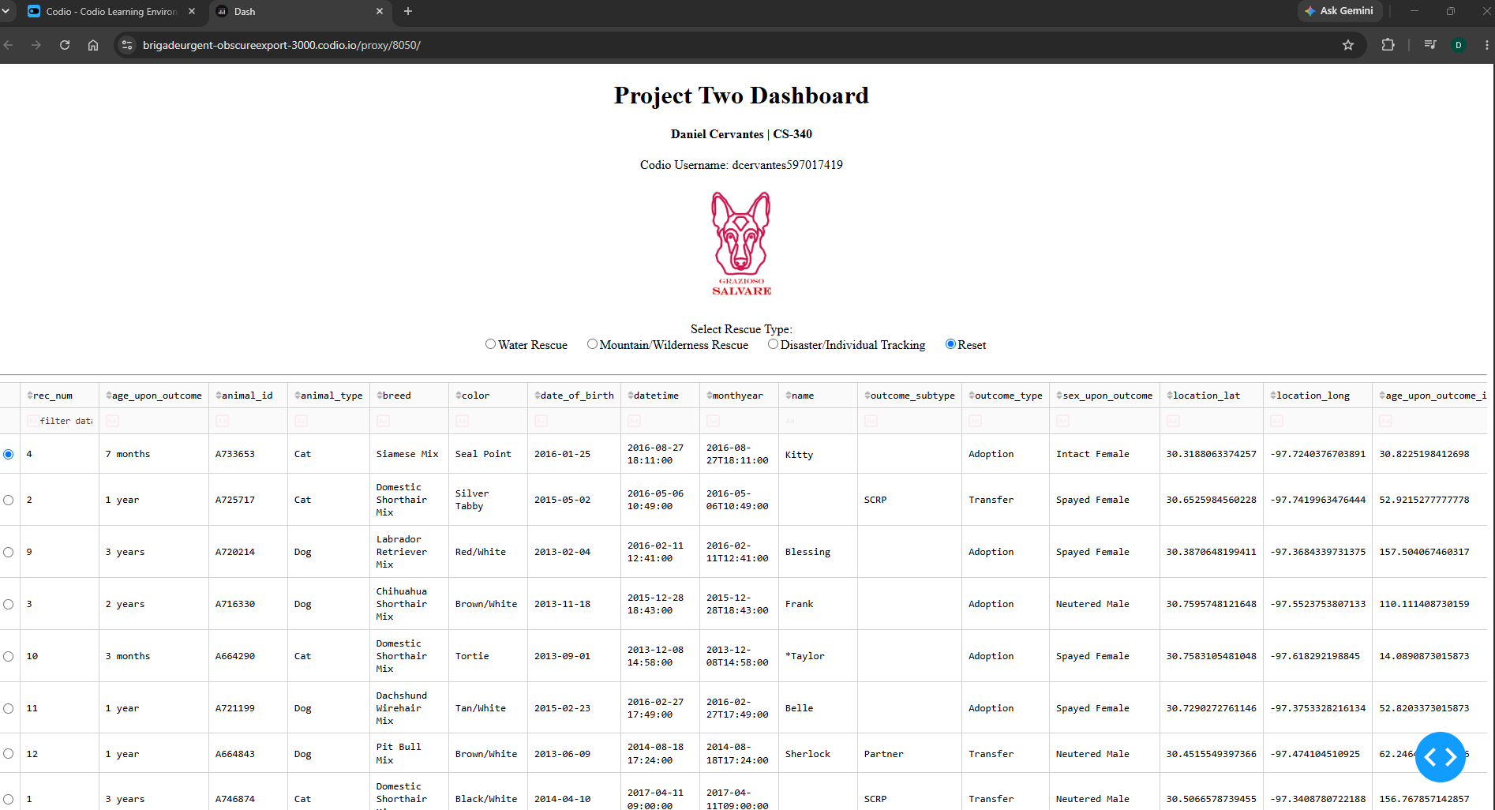
Figure 1. The initial Grazioso Salvare dashboard displays the project information, organization logo, rescue filters, and animal data table.
Figure 2: Water Rescue Filter
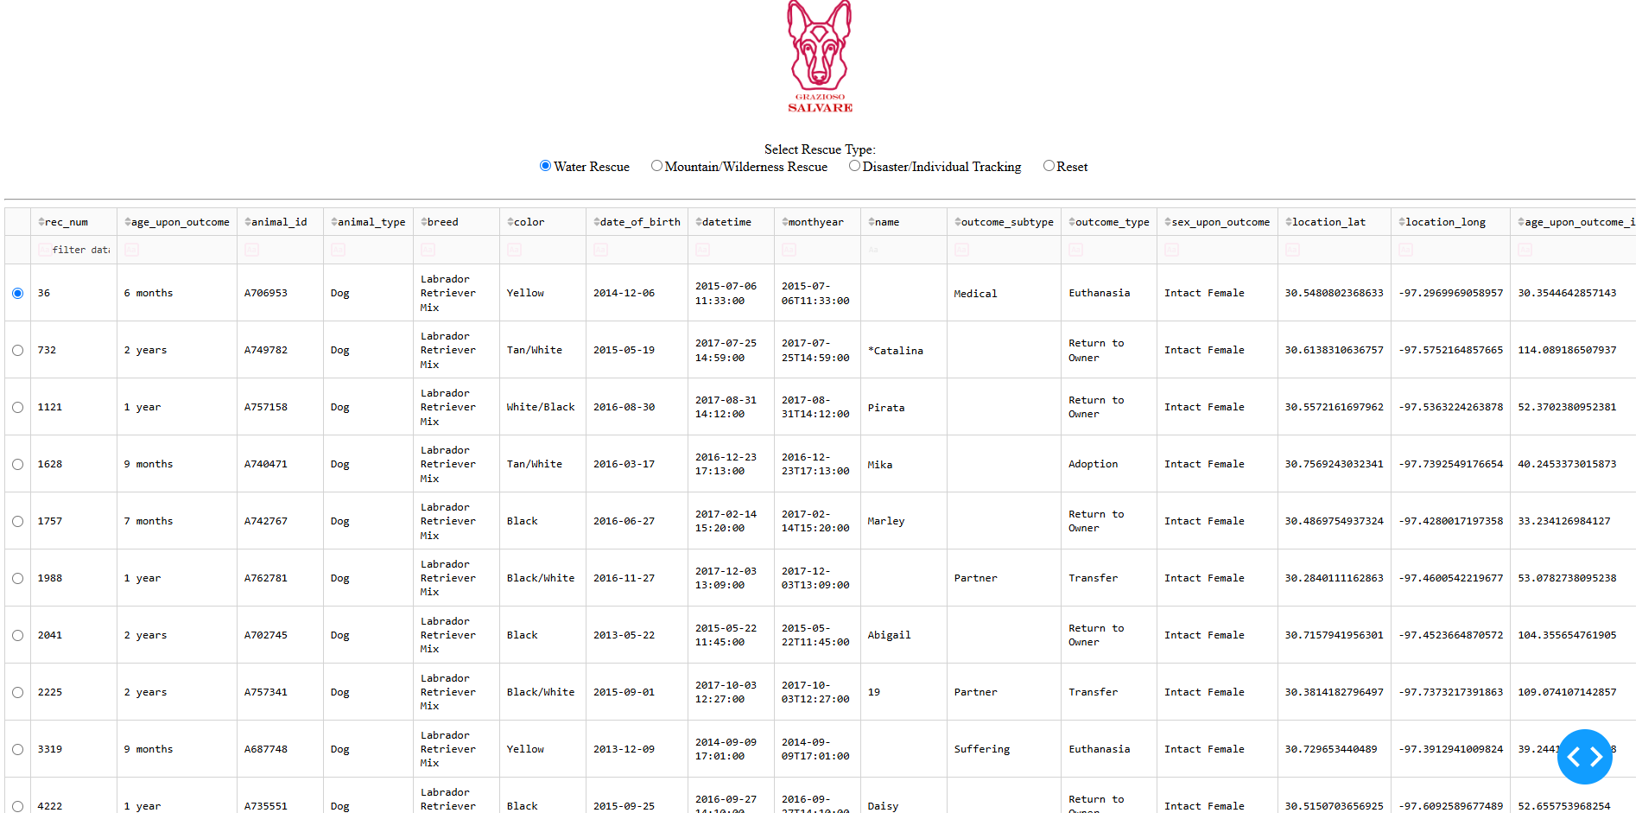
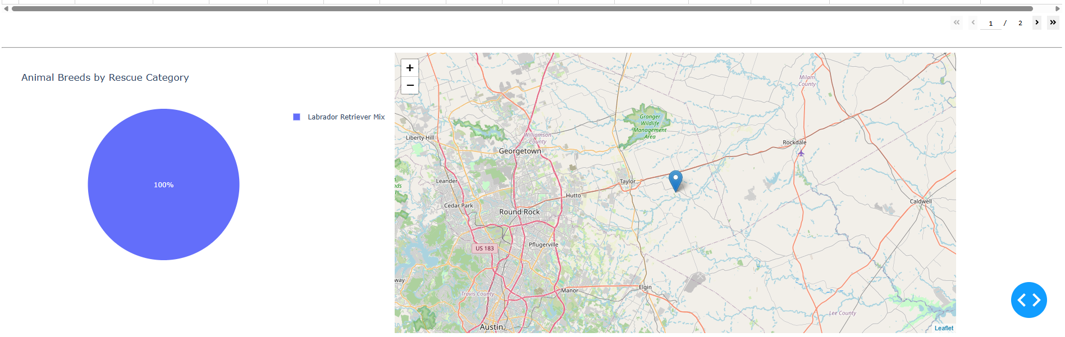
Figure 2. The Water Rescue filter displays matching dogs based on breed, sex, and age. The pie chart updates to show the breeds represented in the filtered results.
Figure 3: Mountain/Wilderness Rescue Filter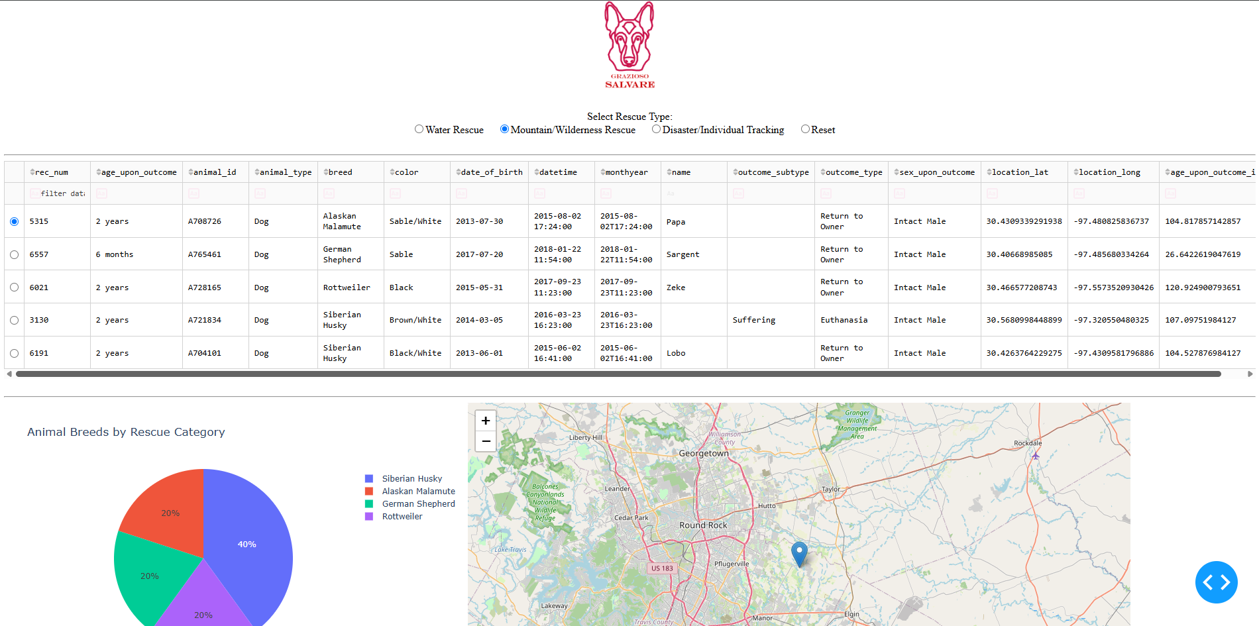
Figure 3. The Mountain/Wilderness Rescue filter displays matching dogs and updates the data table, breed pie chart, and location map.
Figure 4: Disaster/Individual Tracking Filter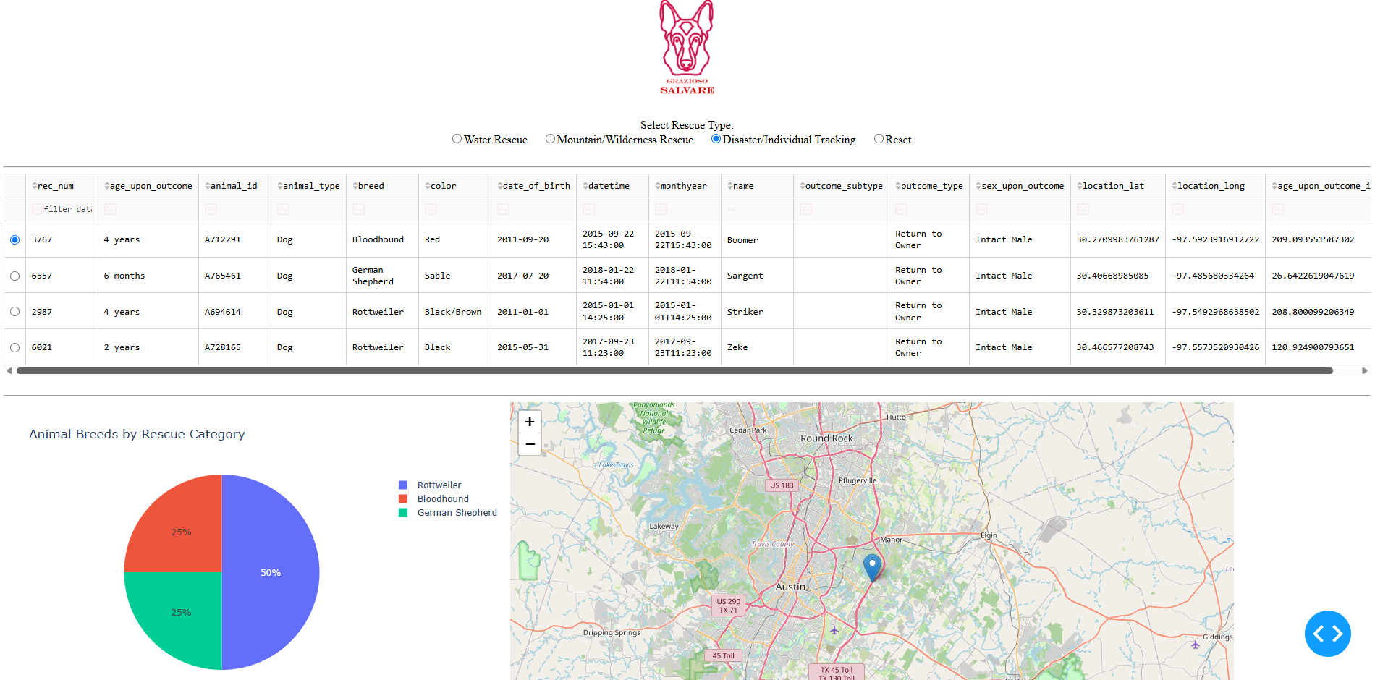
Figure 4. The Disaster/Individual Tracking filter displays four matching dogs. The pie chart shows two Rottweilers, one Bloodhound, and one German Shepherd.
Figure 5: Reset Filter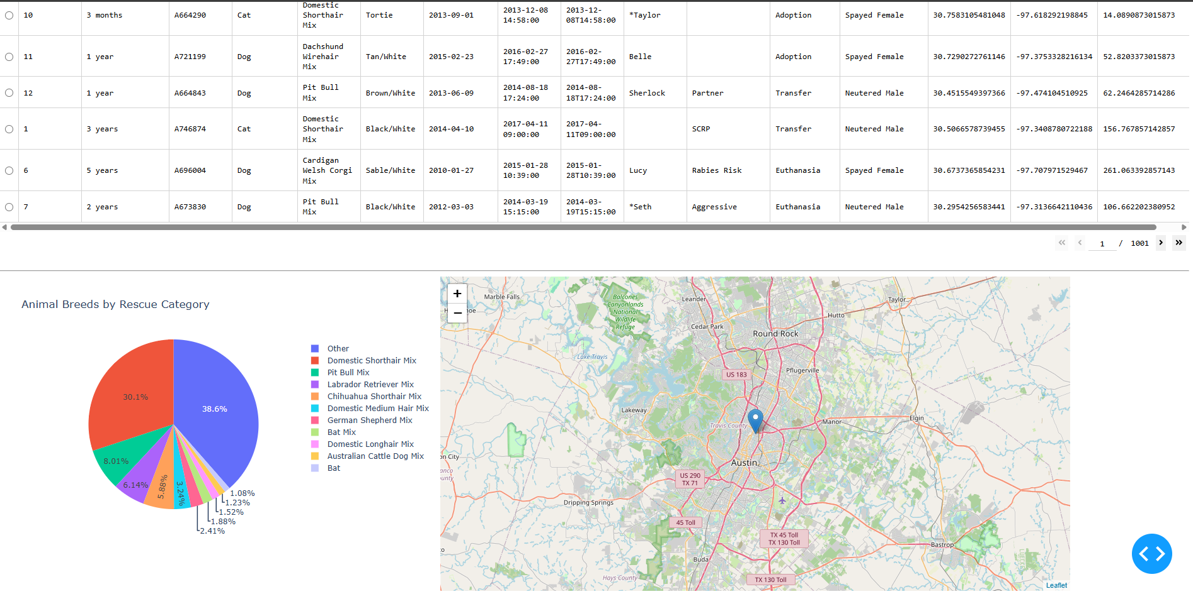
Figure 5. The Reset option restores the complete animal shelter dataset. The pie chart displays the 10 most common breeds and groups the remaining breeds into an Other category.
Testing Results
During testing, I confirmed that all four rescue filter options worked as expected. The data table displayed the matching animal records, and the pie chart updated based on the selected filter.
I also tested the interactive map by selecting a different animal from the data table. The map updated to show the selected animal's location, and clicking the marker displayed the animal's name.
These tests showed that the dashboard could retrieve animal records from MongoDB, filter the information, and display the results through interactive components.
Project Reflection
I was able to take the CRUD Python module I developed earlier in the course and use it to create an interactive dashboard. This helped me understand how MongoDB, Python, and Dash can work together to build an application that displays information from a database.
One of the challenges I faced was getting all the dashboard components to work together correctly. I had to make sure the rescue filters returned the right animals and that the data table, pie chart, and map updated based on the selected information. I also had to troubleshoot the Grazioso Salvare logo so it would display correctly in Codio.
Testing each feature helped me identify problems and make improvements. I learned more about using callbacks in Dash, working with MongoDB queries, and displaying database information through interactive charts and maps.
This project gave me more experience connecting a database to a user interface and showed me how these skills can be used to create applications that make information easier for users to access and understand.

Resources and Software Used
MongoDB documentation: https://www.mongodb.com/docs/
PyMongo documentation: https://pymongo.readthedocs.io/
Dash documentation: https://dash.plotly.com/
Pandas documentation: https://pandas.pydata.org/docs/
Plotly Python documentation: https://plotly.com/python/
Dash Leaflet project: https://github.com/emilhe/dash-leaflet
JupyterLab documentation: https://jupyterlab.readthedocs.io/
Python PEP 8 style guide: https://peps.python.org/pep-0008/
Austin Animal Center Outcomes dataset: Austin Animal Center (2020), https://doi.org/10.26000/025.000001
SNHU CS 340 Project Two Guidelines and Dashboard Specifications Document (course materials).

